OPTION B
This option is my favorite. It allows one to fix their SVS fault the fastest and is a more permanent repair compared to OPTION A.
So how does this work?
Answer: The SLABS ECU uses one wire to get a signal from the SVS. The signals the SLABS ECU monitors are; SVS CLOSED, OPEN, or ONE OPEN, ONE CLOSED. If the SLABS ECU senses an open in the circuit, the Three Amigos pay a visit. So having messed up the SVS plug circuit board I needed to find a way to replicate this "monitoring" by bypassing the circuit board completely, I needed to figure out the missing link between the YG wire and the two pins on the circuit board. As it turned out, one SVS pin went to ground, and the other went to the YG wire. THAT WAS IT!
I tested it using a customer's DII. I took my SVS and placed it on the customer's ABS pump. I cut into his YG wire, ran a wire from there to the SVS plug, then ran another separate wire from ground to the other pin on the SVS plug. I tested for Ohms and boom... I passed at OPEN, CLOSED, and ONE Open.
That told me that I don't need to do OPTION A.... EVER... I don't need to mess with that little SVS circuit board and risk cutting it up. It became clear this method was better.
Hopefully I have won you over on your decision to do option B.... so let's do it!
37. You need to decide how you want to connect and run the wires. Read through all of OPTION B to get a better understanding. I chose a trailer connector harness for a few bucks. I cut my connector 3/4 of the length.
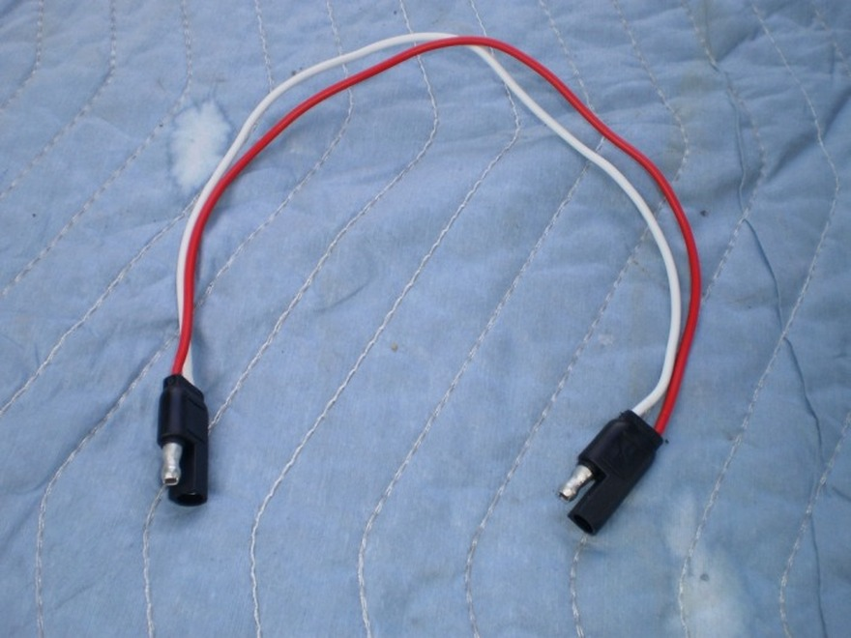
38. Remove your SVS any method you desire, Option A, or Option B without removing the modulator side (see steps # 25 through # 29) Cut SVS plug, but unlike my cut illustrated below, cut as close to the plug as possible.
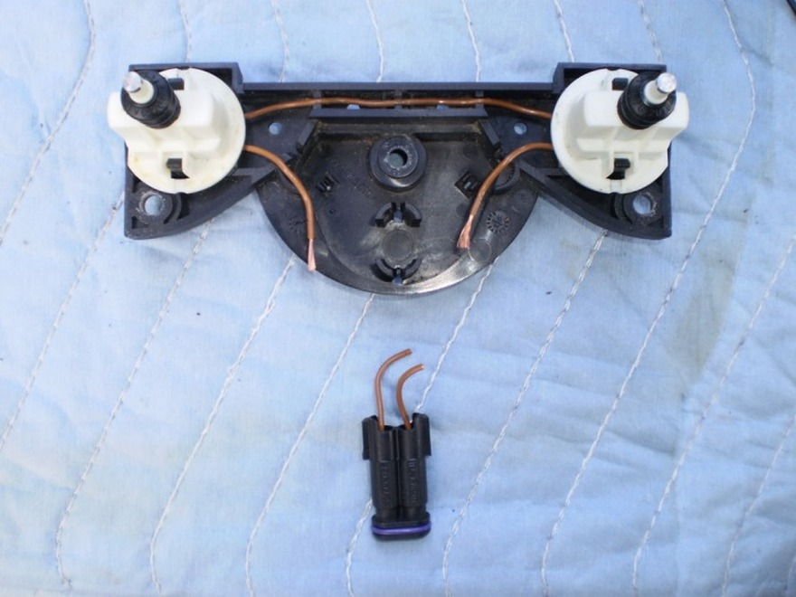
39. Splice, solder, and heat shrink the longer end of the trailer connector to the SVS wires and run them through the SVS cover plate.
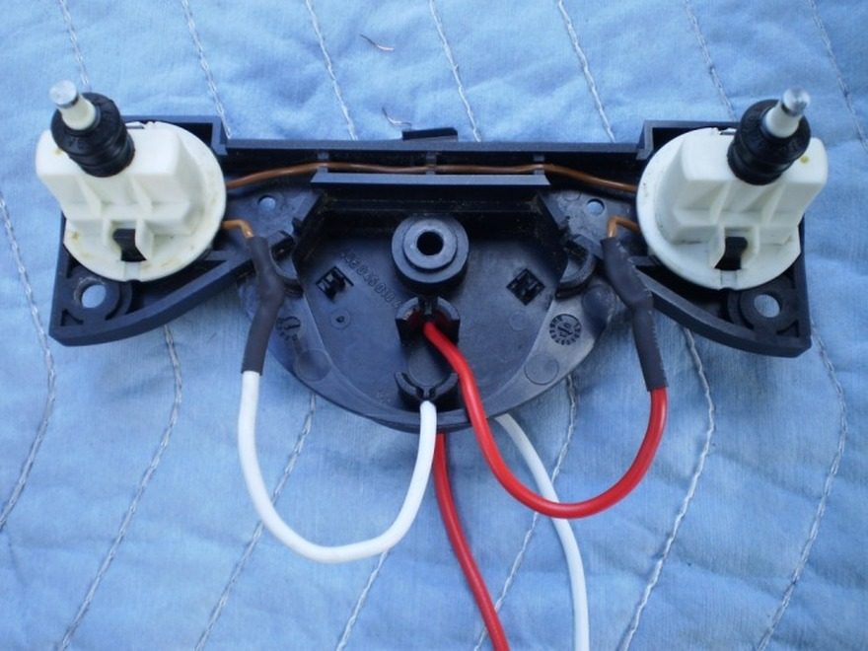
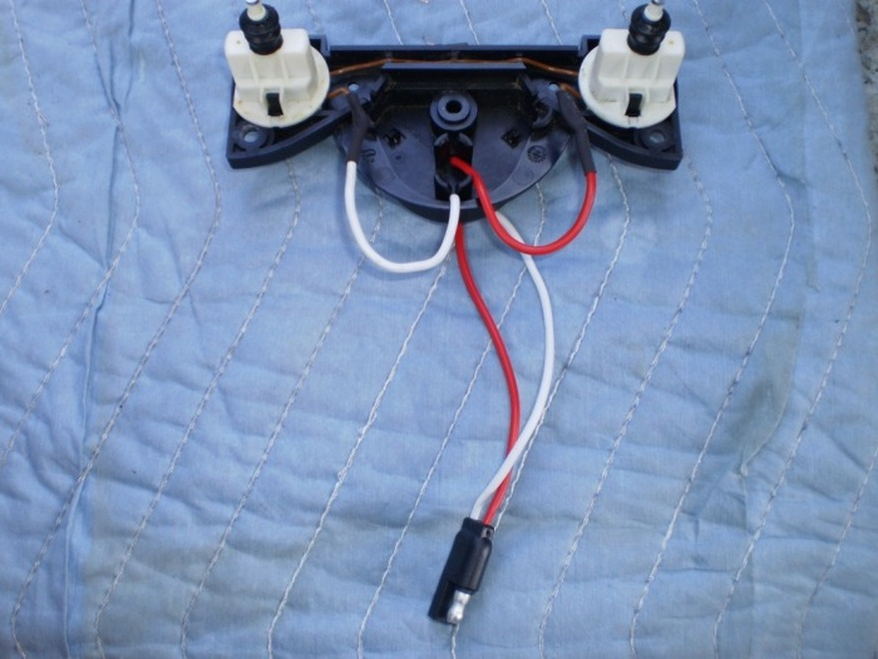
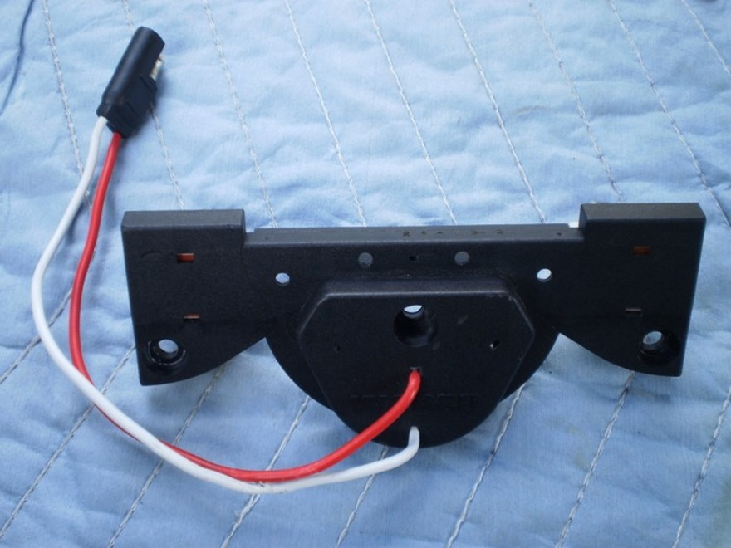
40. Now to test the connections.
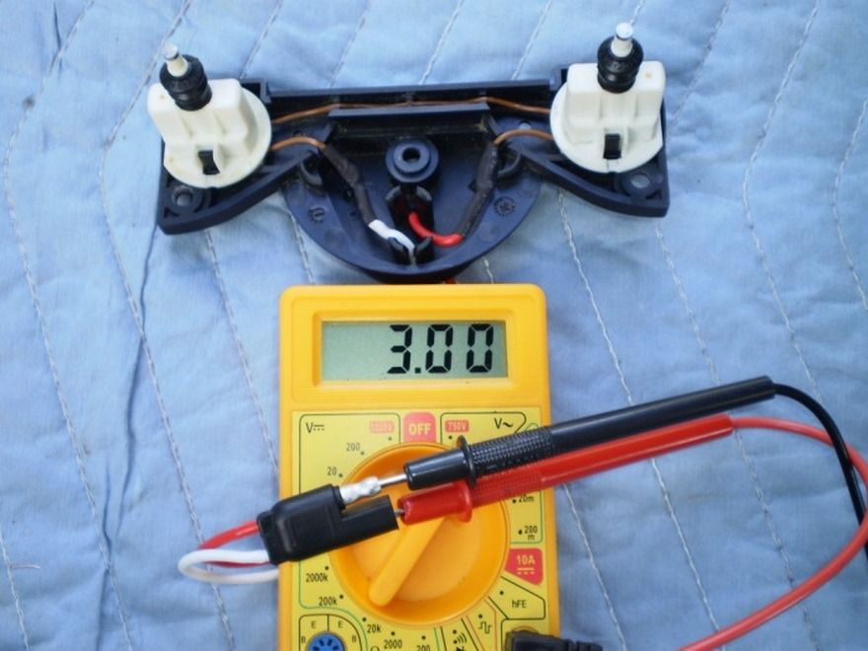
BOTH open, PASSED.
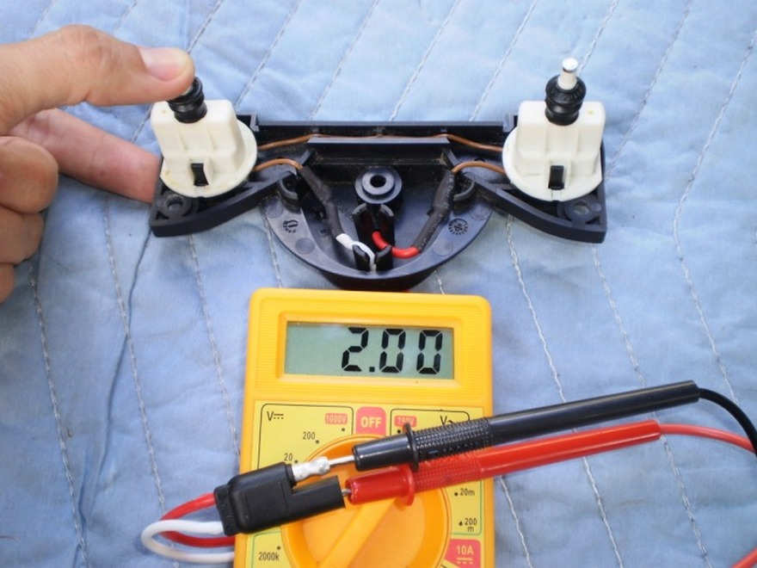
ONE Closed, PASSED.
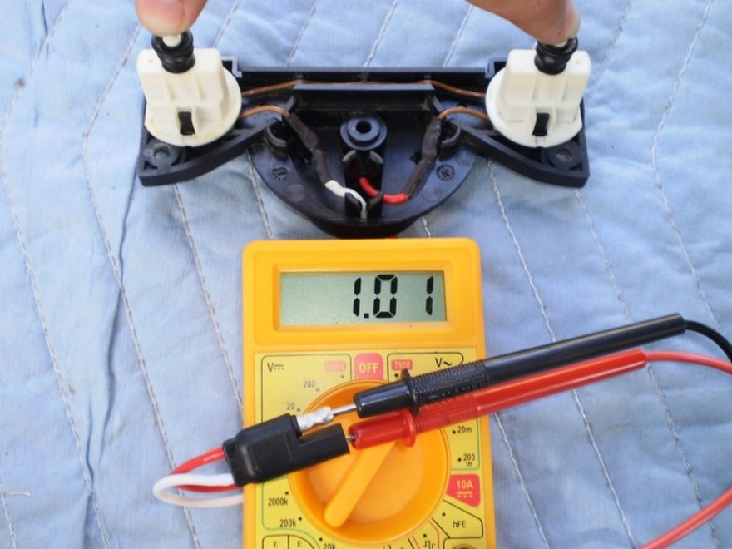
BOTH Closed, PASSED.
41. Now to find a close ground.... Since the YG wire we need to tap into runs along side the A/C line bracket retaining bolt.. Why not use it?
****UPDATE April 22, 2010****
The Three Amigos returned in April 2010 as a result of this bolt coming loose. I may not have tightened it well when I did it the first time back in November 2009 so torque it good, and add loctite. I plan to check the bolt every oil change. In addition to using that bolt as a ground, ensure that it is free of dirt or rust or anything that would diminish a good electrical contact.
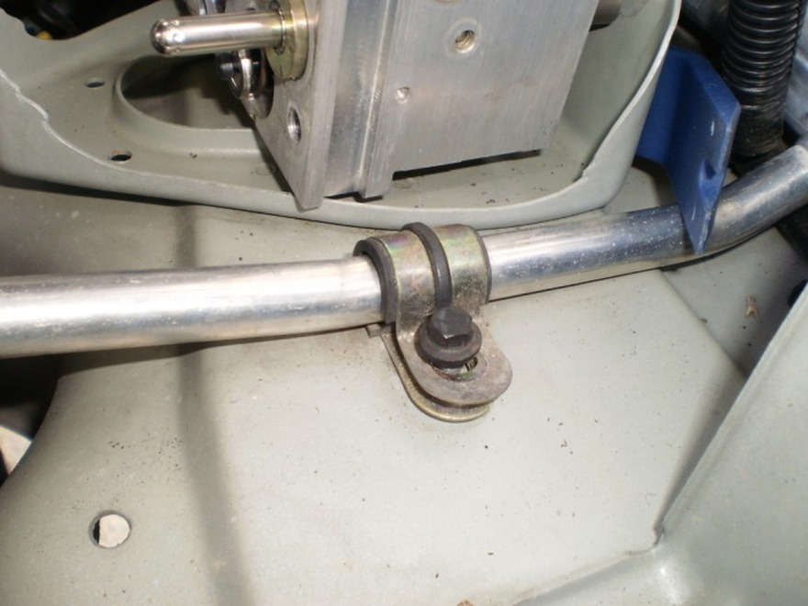
42. Take your other end of the harness and crimp a connector to secure to the ground bolt. Heat shrink it to provide better protection and it also just looks better.
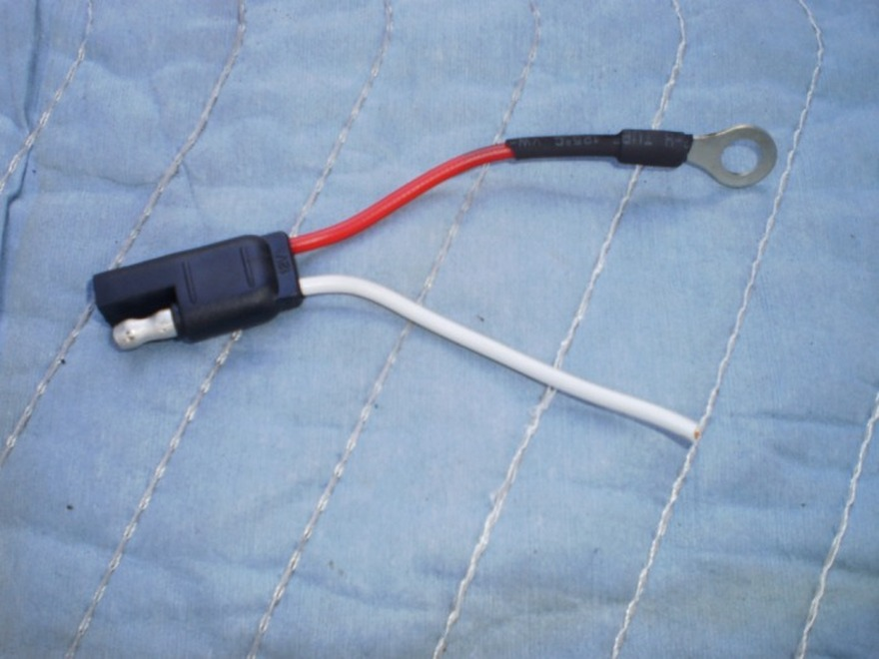
43. Peel off the wire loom shield off of the ABS Modulator wire harness. Locate the YG wire. Cut it in half but in such a way to leave enough length for your harness.
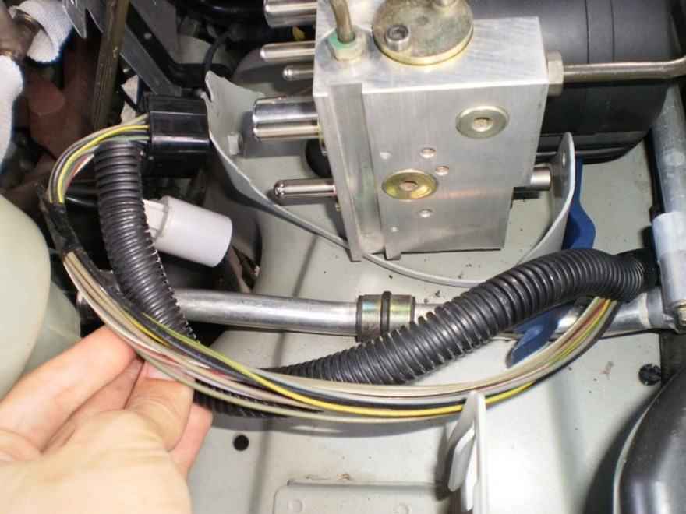
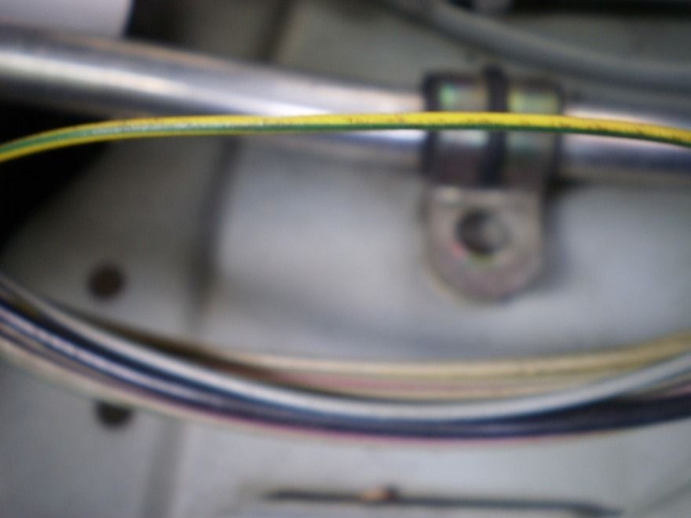
44. Take the second wire from your trailer harness and splice, solder, and heat shrink it into the YG wire coming from the main harness end NOT the end going backt to the modulator plug.
Connect the ground wire to the ground bolt.
Based on comments and feed back, I should add and clarify that the remaining end of the YG wire (the end attached to the plug) will just get tucked back into the loom as it is now dead.
Note** It does not matter which wire of the Trailer harness goes to ground or the YG wire. In other words, it doesn't matter which wire from the SVS goes to either GROUND or the YG wire as long as ONE goes YG wire, and the SECOND to GROUND. (So in my case I could have chosen either white or red wire)
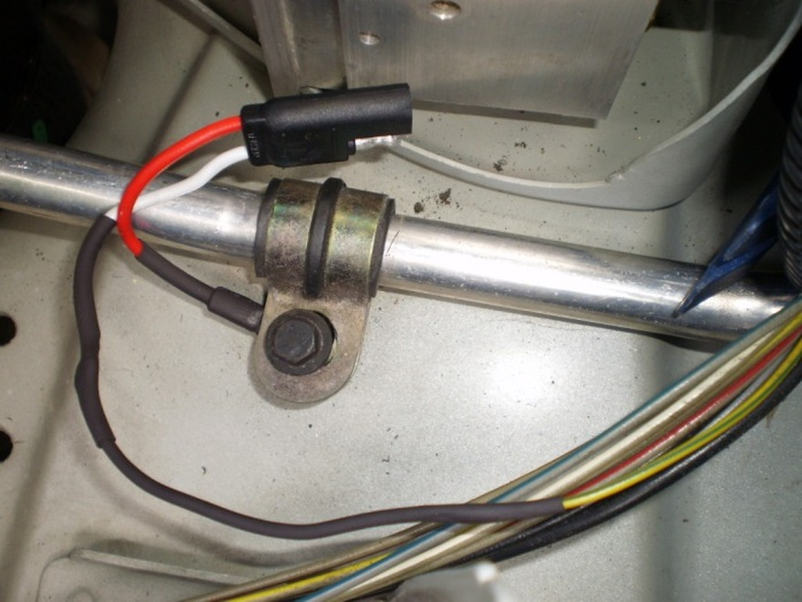
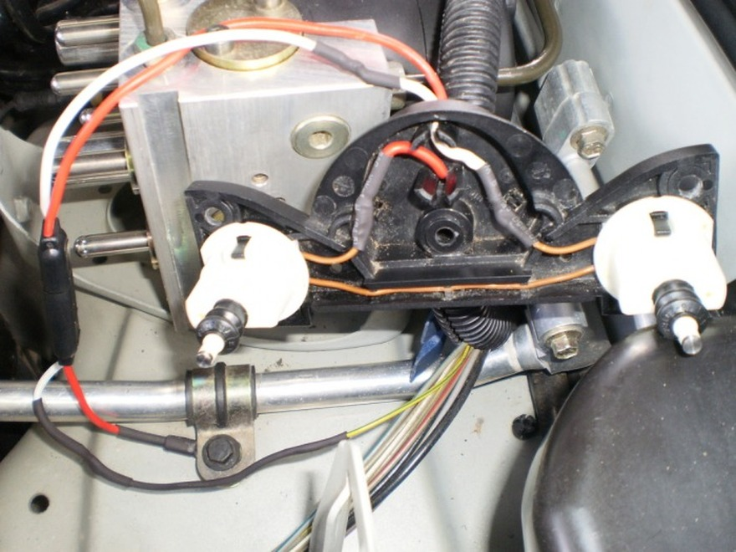
This is what it looks like plugged up.
45. Everything installed, tested, no Amigos, no SLABS trouble codes. Installation is the reverse of removal for any method chosen to remove the SVS.




