Replacing Shuttle Valve Seals

7/2011
If you have the three amigos due to the faults I mention in my ABS Modulator repair, be advised that the SECOND cause for them are leaking Shuttle Valve Seals. Once the brake fluid leaks passed the seals, it finds a new home sitting on the switches. Although the switches are protected with rubber boots, brake fluid still manages to find its way inside the switch and once inside, your SVS three amigos may become permanent.
Luckily the team at FalconWorks Arizona have put together a kit to replace the seals. I highly recommend, (like they do) to do this job right and only once, so if when you remove your SVS to test for ohm, and find them lubed with brake fluid, chances are they may soon fail so get a new set of switches too. Follow the instructions included in the seals kit.
Disclaimer:
Use this guide at your own risk!!!!
Before attempting this repair, read the ABS trouble codes stored on the SLABS ECU to verify it is not another issue. A specialized scanner is required to read and clear the code(s). An intermittent fault will clear itself after shutting the engine off and restarting it. It will not however clear the faults from the SLABS ECU memory.
Having intermittent codes stored in memory will not cause the three amigos to come on. Only current active faults cause them to display.
I REPEAT, use this guide at your own risk!!!! This FIX is not the "CURE ALL" for the THREE AMIGOS but has helped many get rid of them.
1. Perform this repair ONE side at a time. Remove ABS Modulator and Shuttle Valve Switch
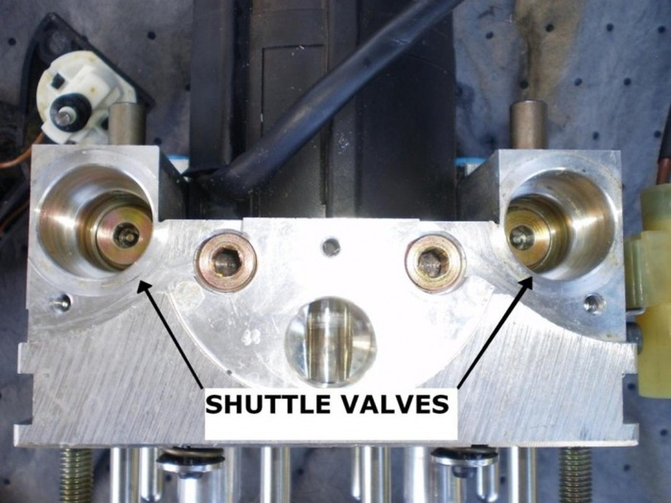
2. Remove the plug with a 6mm HEX key. Use magnet to lift out.
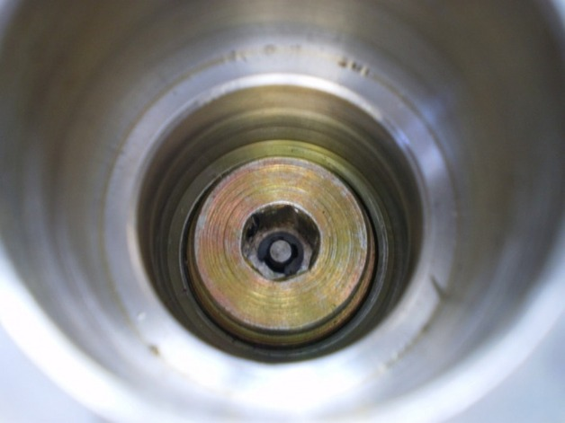
STEPS # 3,4,5 Need NOT be done. You can pull the entire assembly out with pliers by grasping the spacer and pulling up.
3. Carefully remove circlip.
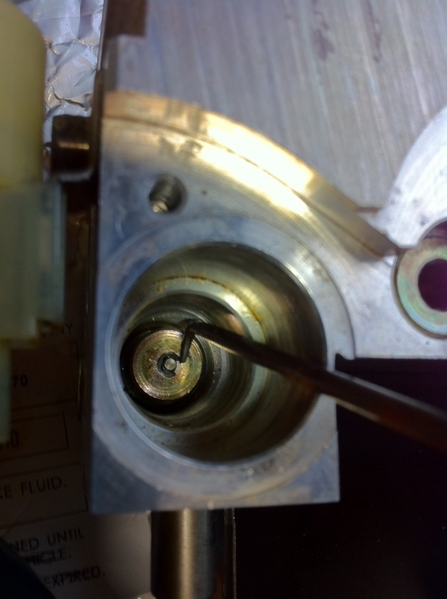
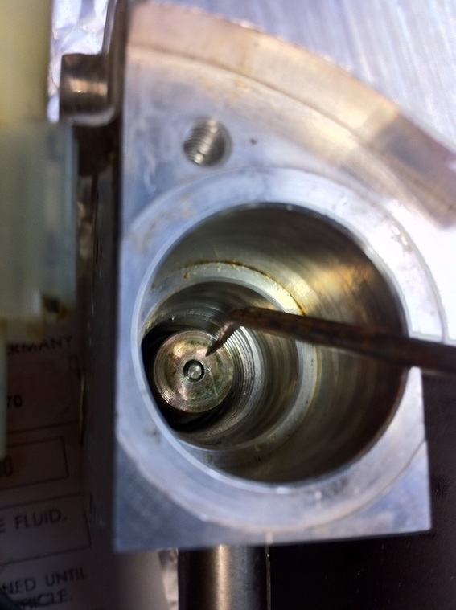
4. Use magnet and remove spacer.
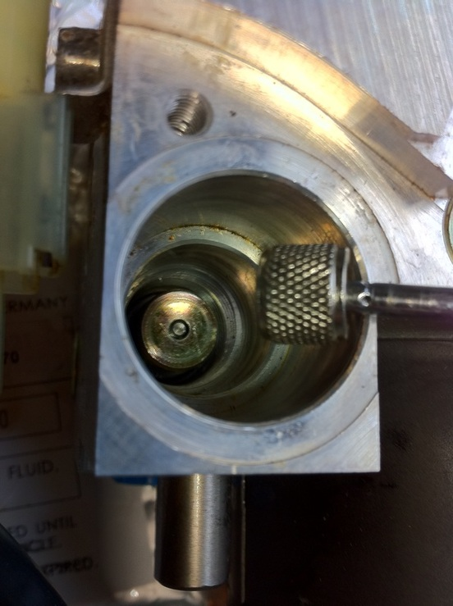
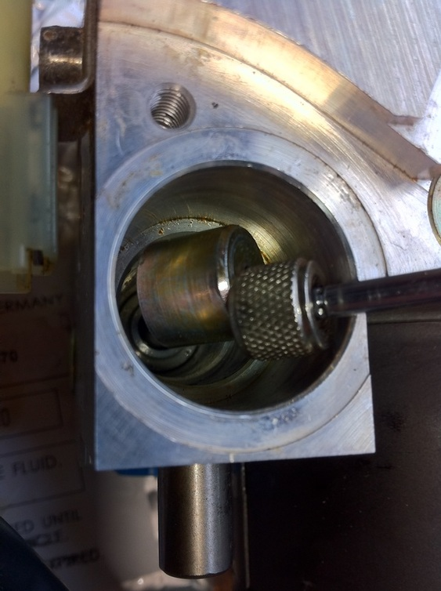
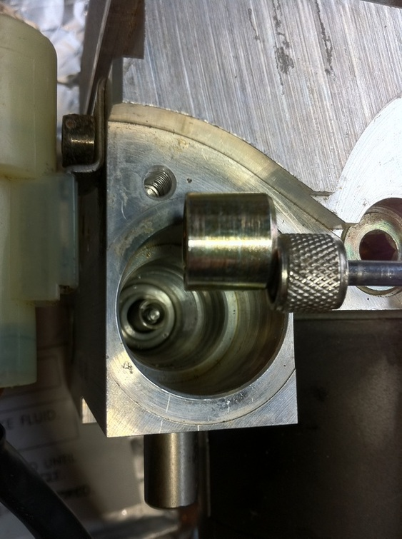
5. Use magnet and remove spring.
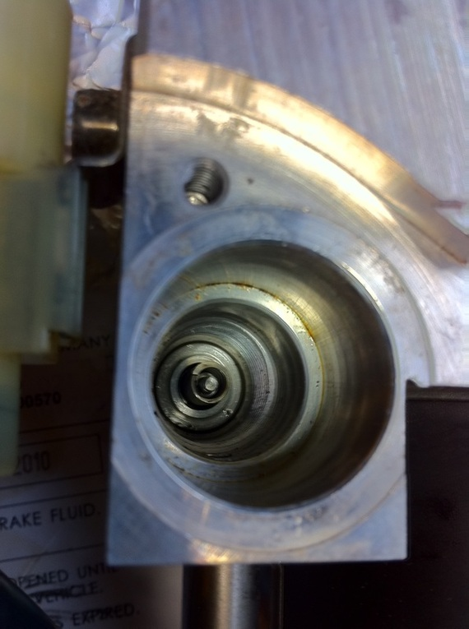
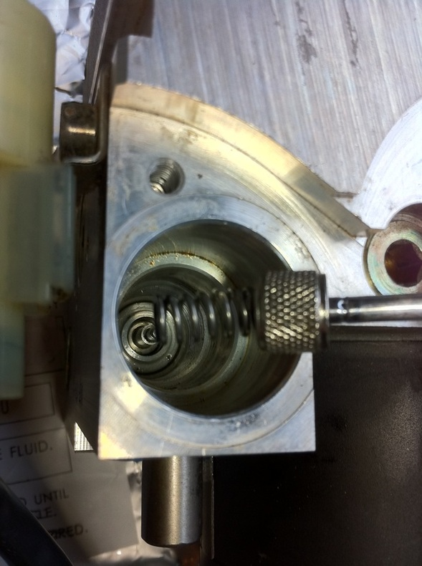
6. Use needle nose pliers (preferably with 45 degree bend) and pull upward on the plunger to remove.
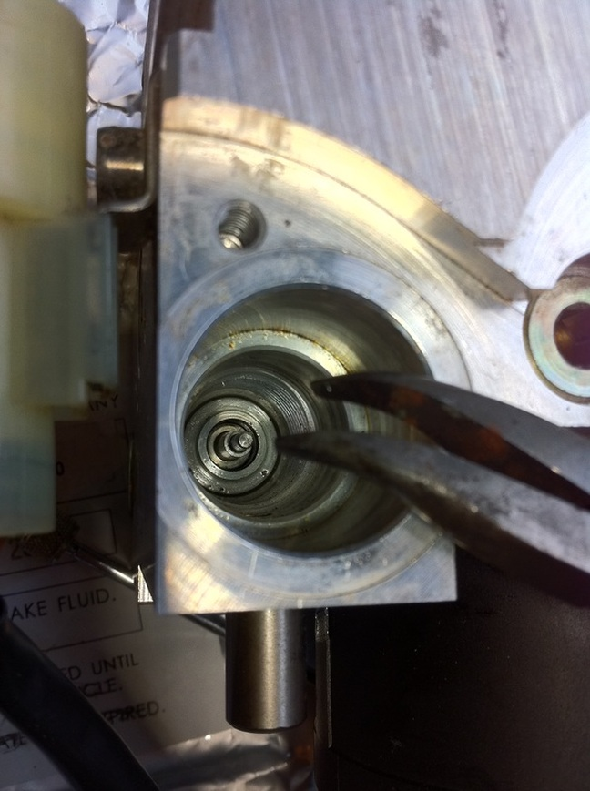
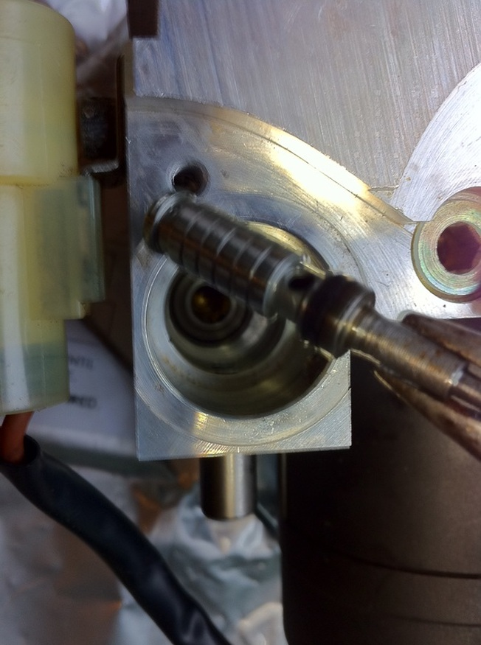
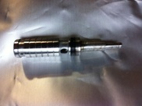
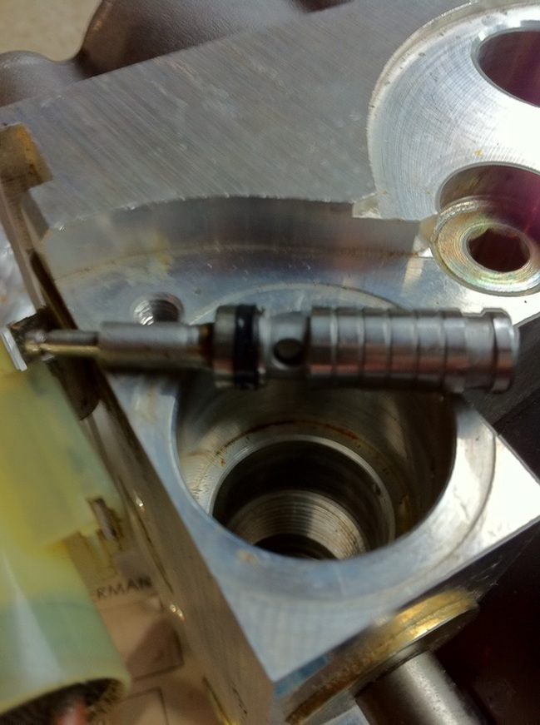
7. Remove seal from plunger.
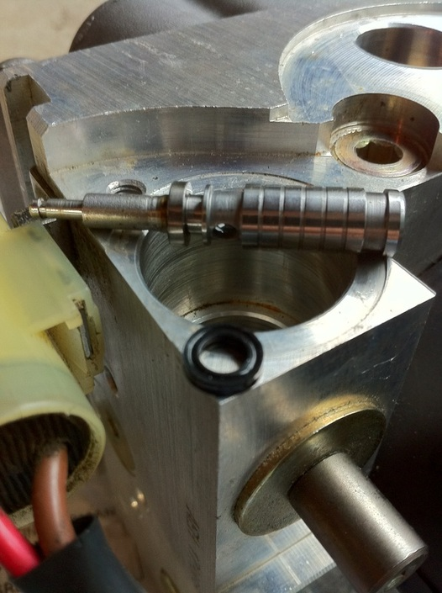
8. Install NEW o-ring.
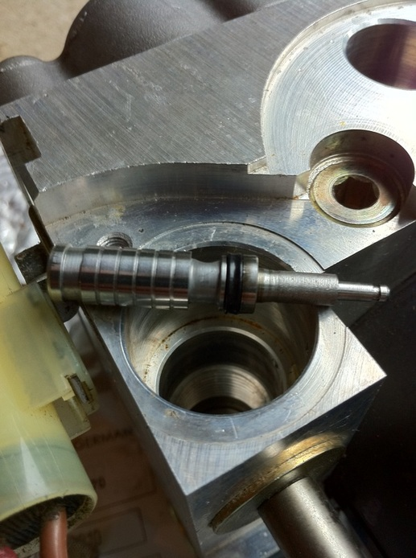
9. Assemble spring.
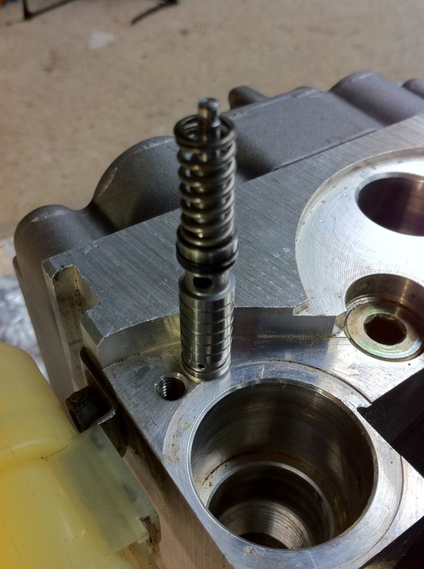
10. Assemble spacer.
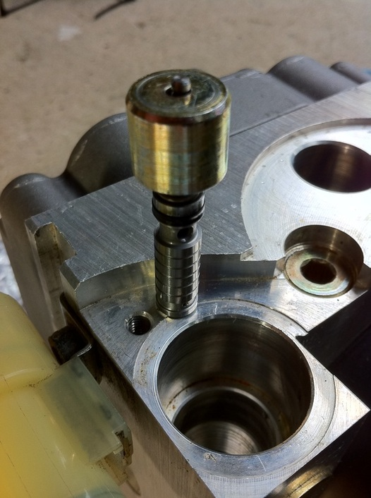
11. Install NEW circlip. (Falconworks instructions call for securing TWO circlips on each plunger)
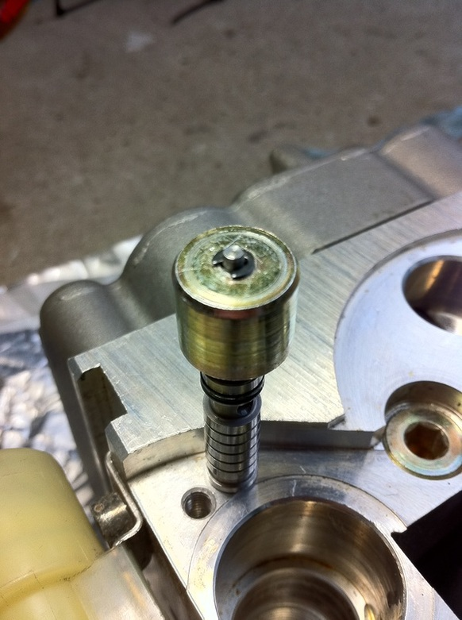
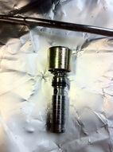
12. Install plunger assembly into modulator. Ensure it goes down fully seated.
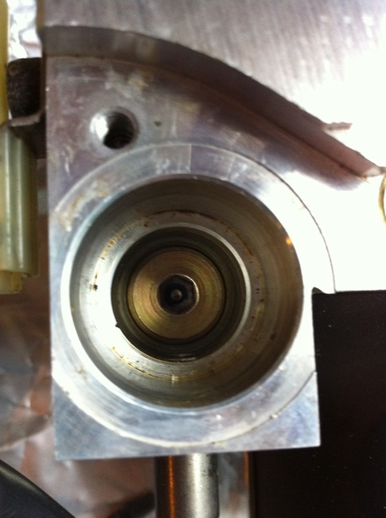
13. Perform option B.
Reinstall Shuttle Valve Switches.
Reinstall ABS Modulator.
Bleed brakes

