Valve diagram Land Rover 2.25 Diesel

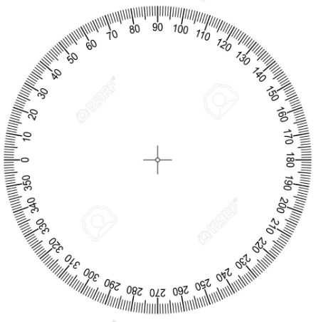

Valve | Valve position | Viewed from flywheel | Viewed from pully
In | Open | 344 | 16
In | Peak | 103 | 257
In | Close | 222 | 138
Out | Open | 129 | 231
Out | Peak | 251 | 109
Out | Close | 13 | 347

Put the engine on TDC on the flywheel. It is assumed that the
Glue or tape the diagram on the pully with the 0-mark pointing up
Make a pointer with for example a piece of stiff iron wire and attach it to the engine block

Now you can nicely determine the angular position of the engine at all times.
Next place a micrometer on top of the outlet valve of cylinder 1. That is the 1st valve from the front of the engine.

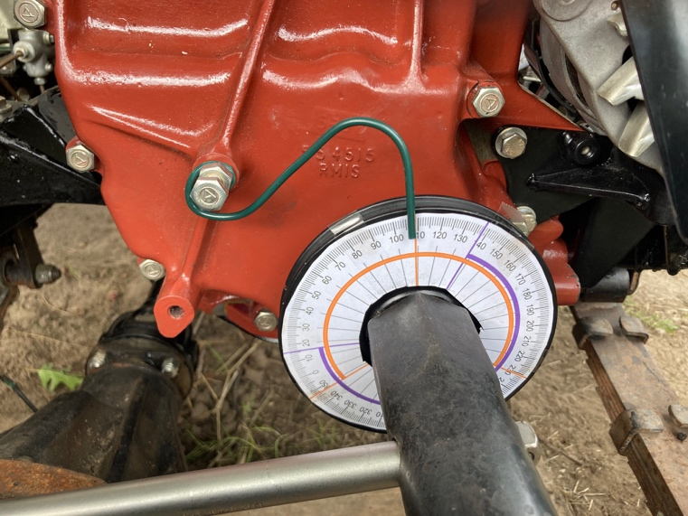
With the micrometer on the outlet valve the maximum opening of the outlet valve can be determined. This should be around 109 degrees. This should match with an EP mark of the flywheel.
Figure 1: Diagram taped to the pully on the front of the engine. With this it is easy to determine the angular position of the crankshaft.
Determining the maximum opening directly is not so easy. Around this maximum the movement of the needle on the micrometer is small. Therefore, the better way is to go at 99 degrees and 119 degrees (10 degrees before and after the peak) and ensure that the micrometer reading is the same. That means the opening at 99 and 119 is symmetrical and from that you can conclude that the maximum is halfway between 99 and 119, hence 109 degrees.
Be careful spinning the engine back, there will be some hysteresis because of the chain tensioner. Best is to always spin the engine clockwise, or at least spin it back for a quarter of a turn.

-- Paul

